Improved design ideas

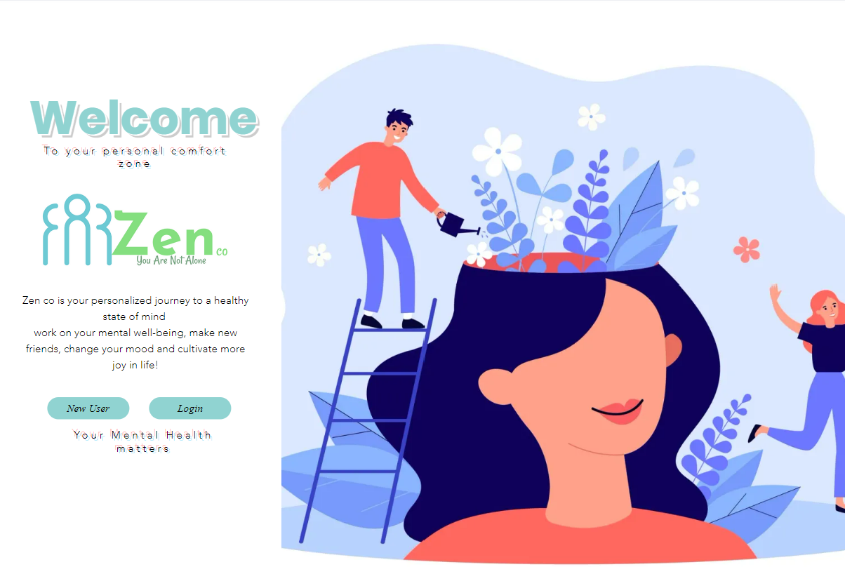

These are the improved ideas based off the feedback from the tutor meeting (15th nov)

* Logo icon improved
* Changed image to suit the idea of mental health
* First image - man flowering head showing the idea of mental health slowly improving as you take care of yourself (stoke adobe image)
* Second image – group holding eachother showing the idea of ‘ fighting struggles together’ or ‘ helping eachother’ (freepik image)
* Removed social media icons/ slightly changed structure

